Are publisher run courses about creative writing, or accounting?

Are courses that promise help to would-be writers really worth the money, asks Liz Thomson
Liz Thomson
Thursday April 11 2013, 1.01am, The Times
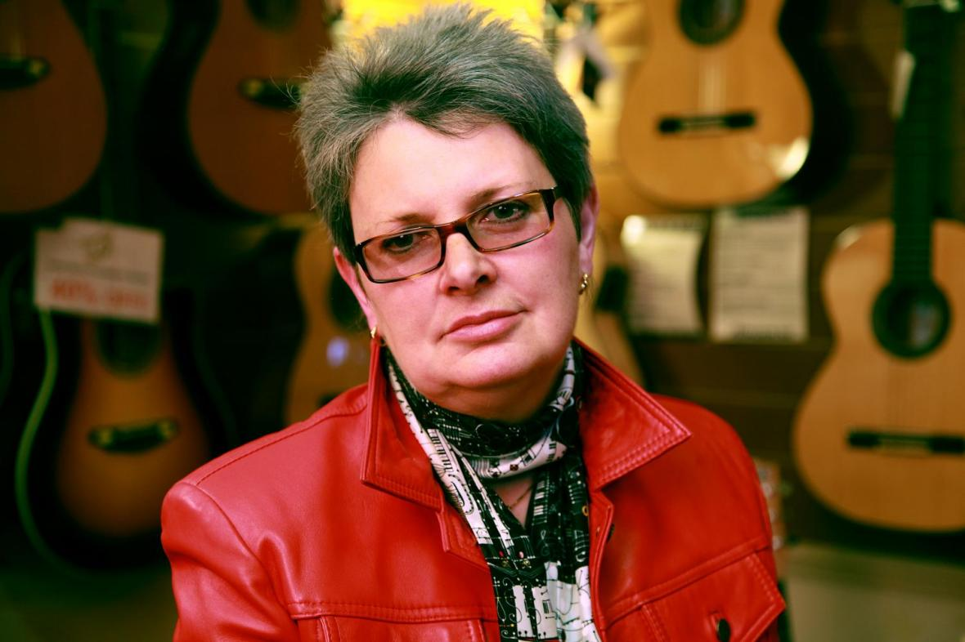
Journalist and writer Liz Thomson investigates the value of writing courses
The banking crisis might have attracted more headlines, but there is also a publishing crisis — or perhaps panic might better describe it. Bottom lines have been battered by a toxic combination of high advances, high discounts and high returns. Meanwhile, digitisation has precipitated all manner of changes in how books are both “produced” and “consumed”.
Staff have been culled, key parts of the publishing process have been outsourced and advances have plummeted, leaving literary agencies, who work on commission, facing a problem. It’s no longer just authors (many of whom earn less than £12,000 a year) who need to be creative.
So what to do? Creative writing courses on campuses began in 1970 with Malcolm Bradbury’s at the University of East Anglia (it has produced three Booker Prize winners: Ian McEwan, Kazuo Ishiguro and Anne Enright), but five years ago a publishing house joined in, when Faber unveiled the Faber Academy, part of CEO Stephen Page’s plan for non-copyright business to make up 15-20 per cent of its revenue. Bloomsbury, via its ownership of The Writers’ & Artists’ Yearbook, and literary agency Curtis Brown, via Curtis Brown Creative (CBC), offer a “suite” of courses, and this weekend Random House enters the market with the The Writers’ Academy From Random House (a two-day course with Audrey Niffenegger, author of The Time Traveler’s Wife).

Creative writing courses are now run by everyone from The Guardian (its courses in partnership with UEA cost up to £7,000; “graduates” are awarded a certificate) to Mumsnet Academy (currently promoting “non-judgmental workshops” with Costa Prize winner Francesca Segal for £299) — but according to those with whom I spoke the quality of courses varies dramatically. “We think publishing is sacrosanct and magical,” says Sarah Dunant, a novelist who teaches a Faber course, “but it’s naive to think it’s immune to the forces of 21st-century capitalism. It’s a wild west market with no sheriff.”

Highly regarded publishers and agents can command up to four-figure sums from hopeful writers by offering tuition from celebrated authors within the walls of their august premises. At Faber and Faber’s “inspiring Georgian offices”, Hanif Kureishi has appeared as a guest tutor on the Writing a Novel course (£4,000), while Poetry and Inspiration: A Muse Boost (£425), includes a lecture by Andrew Motion.
Bloomsbury’s Writers &amp; Artists is marketed along similar lines: its How to Hook an Agent (£149), is held “in historic surroundings at Bloomsbury Publishing, home to authors including Margaret Atwood and J. K. Rowling” and promises a “chance to get noticed”. It also offers Bespoke Mentoring (£1,500-£2,650) and First Draft (£180-£360) or Full Manuscript (£680 to £1,020) reviews.
So is it worth paying premium rates when advances for debut novels can be as low as £500? One would-be novelist — who invested in a “a hands on structural edit” leading to a critique of between five and 10 pages — told me that her “mentor” responded with fewer than four, the first paragraph of which explained the nature of science fiction, although the book under consideration was a romantic comedy. “It felt thrown together,” Julia told me, “perhaps even using a standard kit of parts with generic paragraphs to pad out the word count. The appraisal had some value but it wasn’t worth £550. In short, I suspect I was fleeced.”
All the publishing courses, however, can claim notable successes. At CBC, four students have found agents, one of whom, Tim Glencross, is represented by Curtis Brown (a win-win situation for the company). A lawyer, and former political speech-writer, his first book Barbarians has subsequently been sold to Fourth Estate by agent Karolina Sutton, whose inspirational talk he’d sat through while on the Novel Writing course. Faber, meanwhile, estimates that “25 or so” of those attending its courses have been signed up, including Rachel Joyce, whose debut, The Unlikely Pilgrimage of Harold Fry (Doubleday), was long-listed for the Man Booker and is now in contention for the Commonwealth Book Prize.

The most successful graduate of Faber’s Writing a Novel is S. J. Watson; the NHS audiologist’s inaugural novel, Before I Go to Sleep (Black Swan) is an international bestseller and is being adapted into a film by Ridley Scott. He met his literary agent, Clare Conville, on his last night on the course.
Would these authors have written these books whether or not they had attended their respective courses? It’s a question that Watson says he is often asked, and he says that the pep talk given by the novelist Louise Doughty on the course gave him permission to think of himself as a writer and the impetus to type “until my fingers bled”.
“We are giving them the tools,” says Dunant, whose course, Stuck in the Middle, enables aspirant novelists to see that the problems they grapple with are the same as those faced by best-selling authors. “We’re passing on what we’ve learned and we’re emphasising that writing is not easy. It’s a journey that involves some suffering.”
For the majority of would-be writers that pain will be for no financial gain. Although doing a course with an agent or publisher encourages them to think they’ve a foot in the door, perhaps two, only a tiny percentage will find a bona fide publisher. Yet, overtly or otherwise, the writing courses seem to play on the belief that, with a little help from the right people, getting published is easy. Publishers (few of whom accept unsolicited manuscripts) and agents (many also now reluctant to read the slush pile) are willing to help empower what in the pre-digital age was mere “vanity publishing” but which, thanks to Kindle et al, we now call self-publishing.
And that is what makes what publishers and agents are doing appear so cynical. Page maybe truthful in claiming “the Faber business is not opportunistic. It genuinely wants to serve reading and writing” but another course provider sneered about “loads of lovely money” from people who “haven’t a hope”.
Like unpaid internships, the cost of most courses makes them prohibitive for many people. Carole Blake, co-founder of the long-established and much-respected Blake Friedmann Agency has no doubts: “If they feel so altruistic about helping unpublished writers, they could charge less. Or do it free and see it as a recruiting drive . . .
I just think it leaves unpublished authors open to exploitation. It is a monetising of the slush pile.”

